Alliance Credit Union Offers Opportunities to CFCC Students

Published in June 30th, 2011
Posted by Dana McKoy in Pressroom
Comments Off

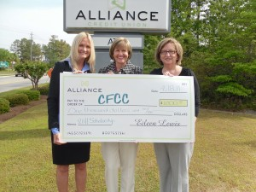
Rachel Robinson (feft) and Ruth Barefoot (right) of Alliance Credit Union present a check to Kay Warren (center) of the CFCC Foundation.
By Maxann Keller, CFCC Foundation Intern
Wilmington, NC- Alliance Credit Union recently gave Cape Fear Community College (CFCC) students the gift of education by establishing a $1,000 scholarship. The award will be available to a second-year business student for the Fall 2011 semester.
Eligible applicants must have a 3.0 or higher GPA and be a resident of New Hanover, Pender, or Brunswick County. To qualify, students must submit an essay describing their interest in the business field, the benefits of receiving the scholarship, and their recent service in the community. The recipient must also become a member of Alliance Credit Union by establishing an account with a minimum balance of $25.
Rachel Robinson, Alliance Credit Union Business Development Officer, said in reference to the scholarship, “We want to give back to the residents of our local community. Helping someone receive an education seemed to be an appropriate way to give back on an individual basis.”
Alliance Credit Union is committed to impacting the community one step at a time. Thus far in 2011, Alliance Credit Union has already assisted in local charitable organizations such as The Carousel Center, Adopt An Angel and Carolina Beach’s LoTide Run, all of which benefit the local community and its residents. “Alliance has great pride in our Wilmington Community with continuing hope to see it flourish,” said Robinson. “We are honored to have the opportunity to help.”
The general CFCC scholarship application can be found on the College’s website at www.cfcc.edu/finaid The Cape Fear Community College Foundation works to sustain and support students, faculty, and the overall mission of the College. For more information regarding Cape Fear Community College scholarships, please contact Kay Warren at 910.362.7331.

